**BIRT**

**1, Create a task in BIRT to accept the parameter value, generate and render the design**

**Aim**

To Create a task in BIRT to accept the parameter value, generate and render the design

**Algorithm**

1. Select project new project
2. Select BI Reporting Toold
3. Select Report Project
4. give project NAME
5. right click on project created
6. Select new report give NAME
7. In Data Explorer select data source select new
8. Select classic model sample data base
9. Select dataset select new
10. Select next
11. Give the query
    1. Select * from tablename
12. Select finish
13. Select result preview
14. In Report items track the table and set the number of columns and rows
15. From the dataset select the column names to the table heading
16. Select Run view report as HTML or any other option

**Output**

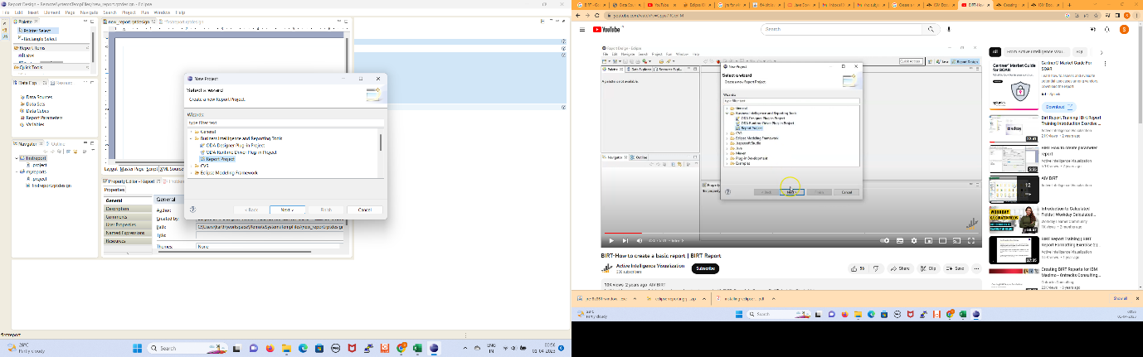

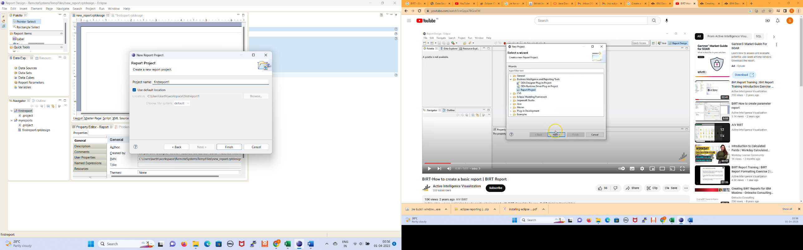

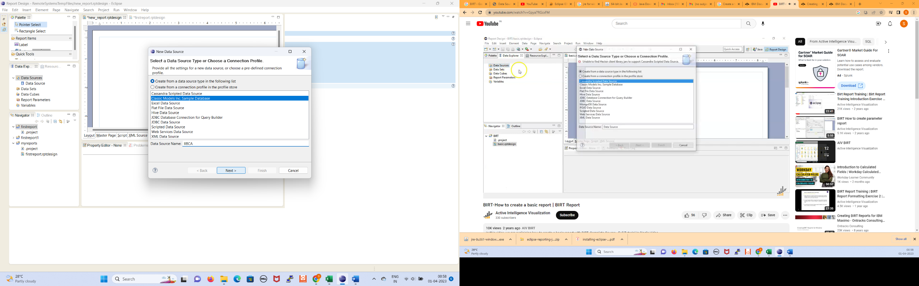

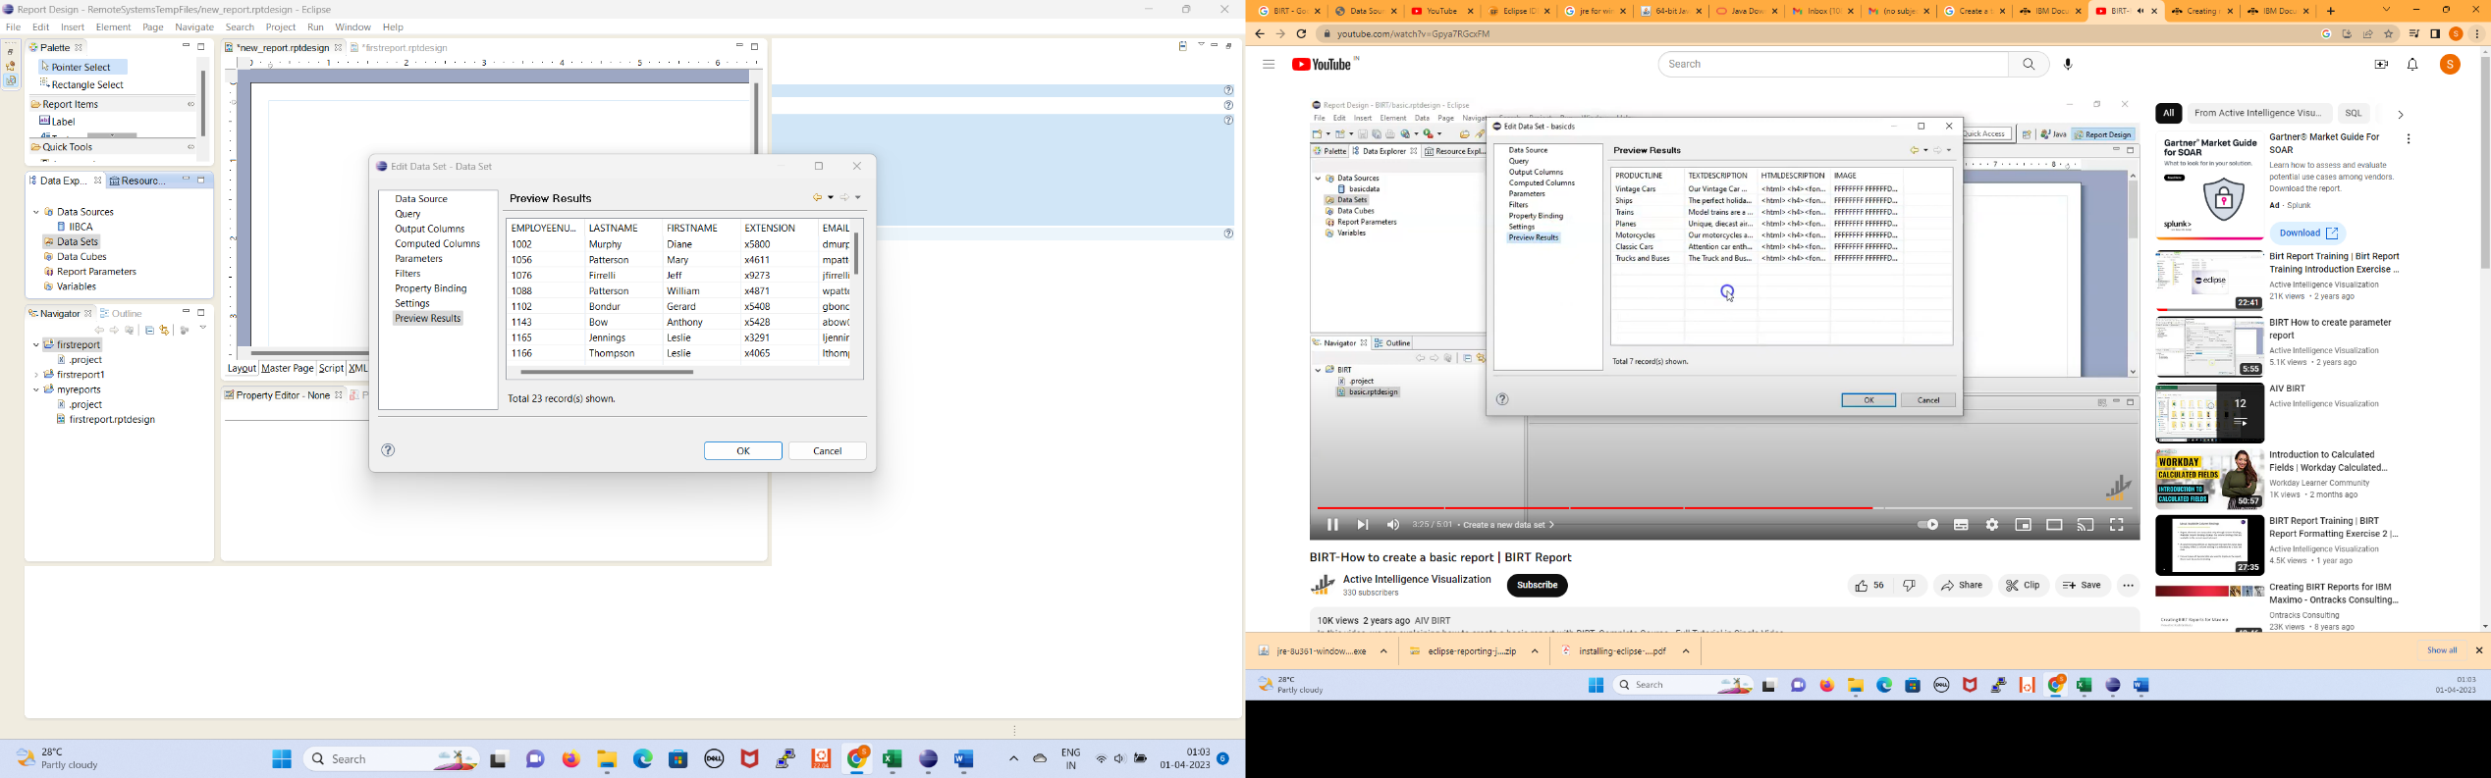

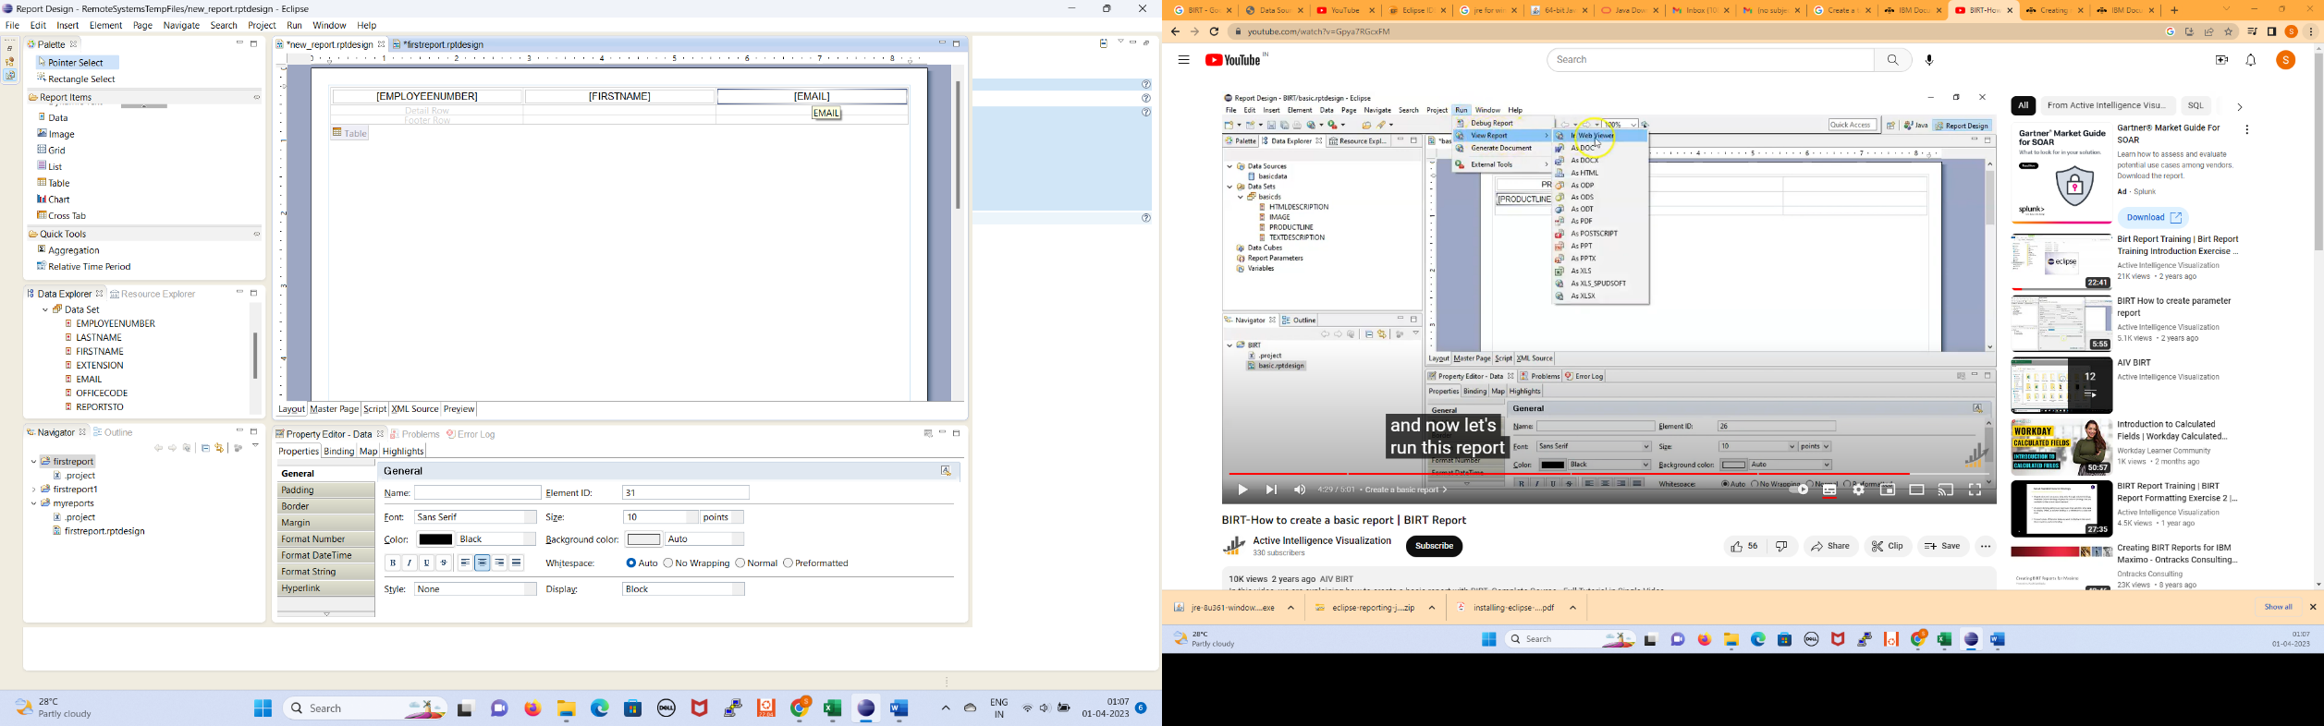

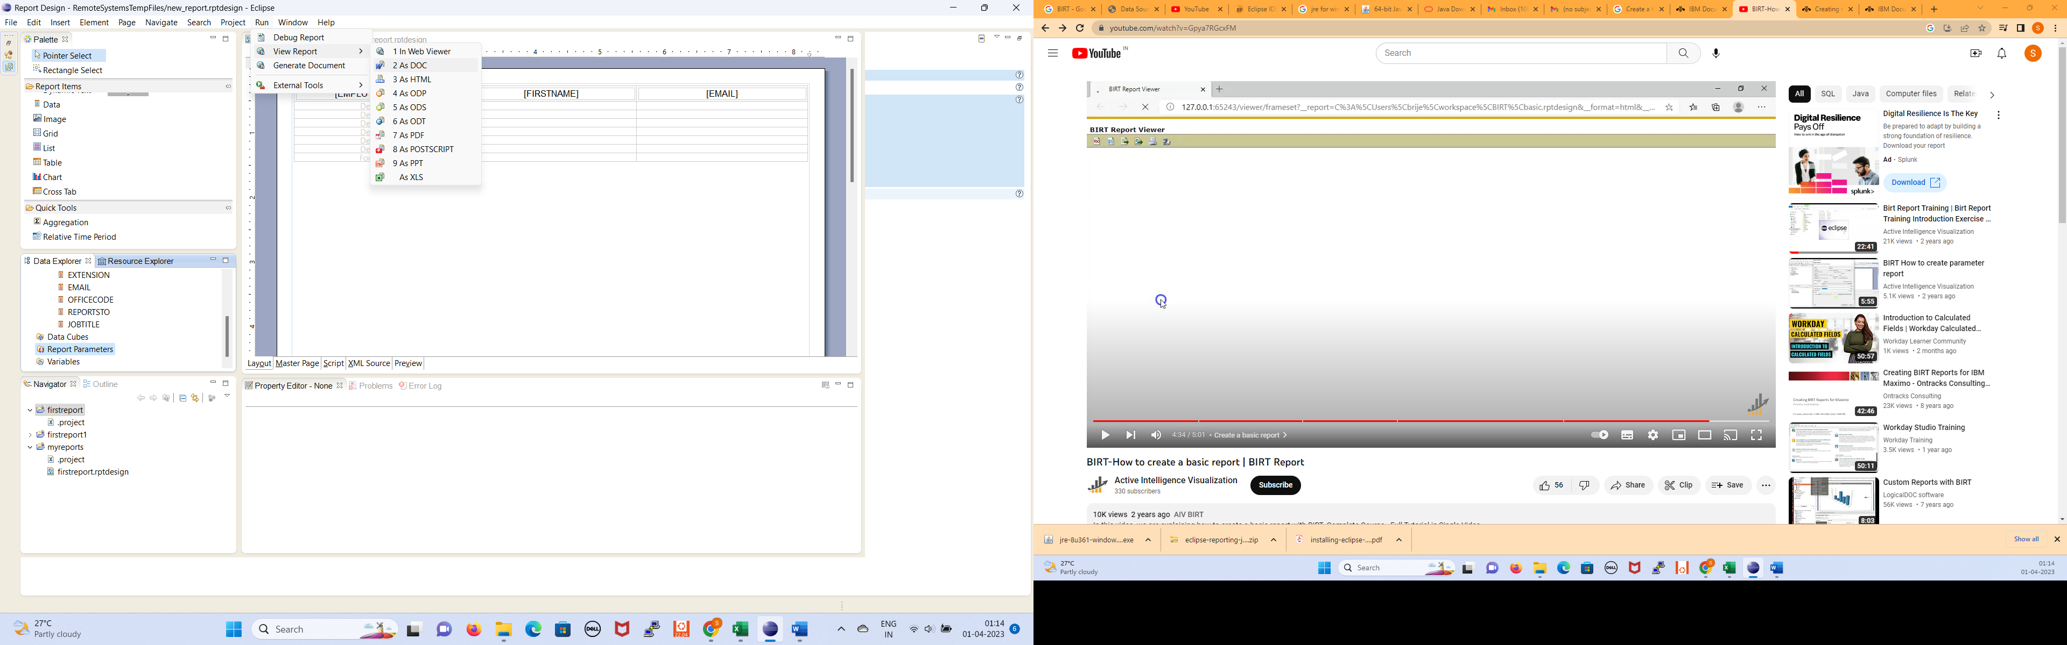

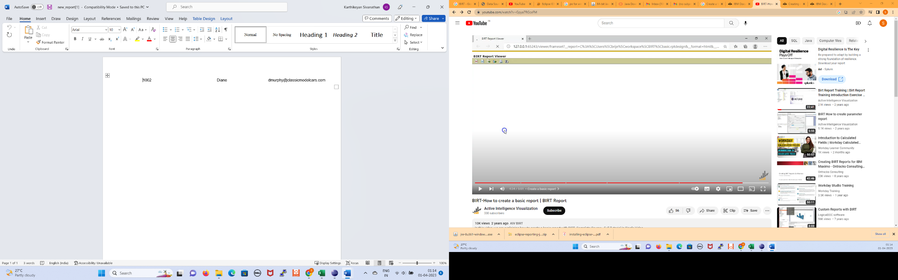

**2. Use BIRT to generate a report for 10 students in alphabetical order**

**Aim**

To Use BIRT to generate a report for 10 students in alphabetical order

**Algorithm**

1. Select project new project
2. Select BI Reporting Toold
3. Select Report Project
4. give project NAME
5. right click on project created
6. Select new report give NAME
7. In Data Explorer select data source select new
8. Select flat file
9. Select dataset select new
10. Select next
11. Select the csv file with data
12. Select finish
13. Select result preview
14. In Report items track the table and set the number of columns and rows
15. From the dataset select the column names to the table heading
16. Select Run view report as Doc or HTML or any other option

**Output**

